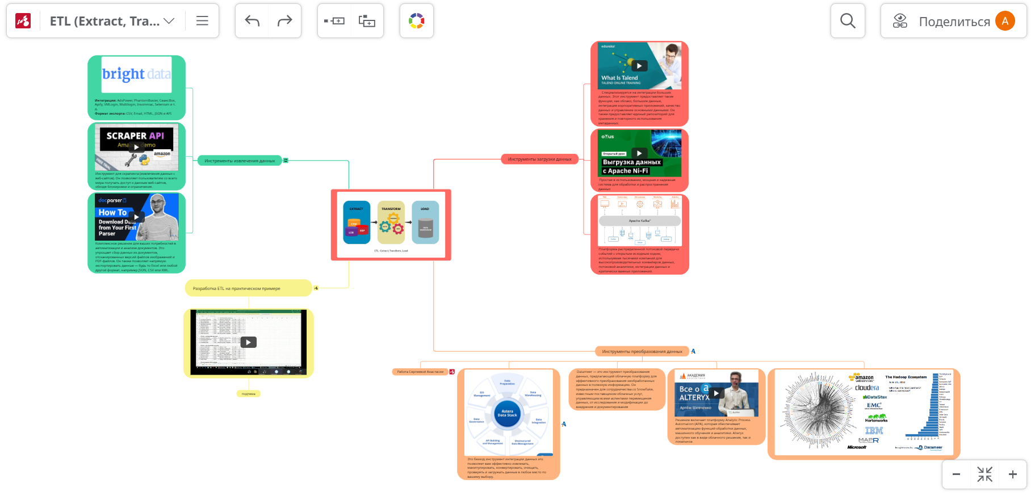

<https://www.mindomo.com/mindmap/623230f54cb445fa9b7d645c4bb15e0a>

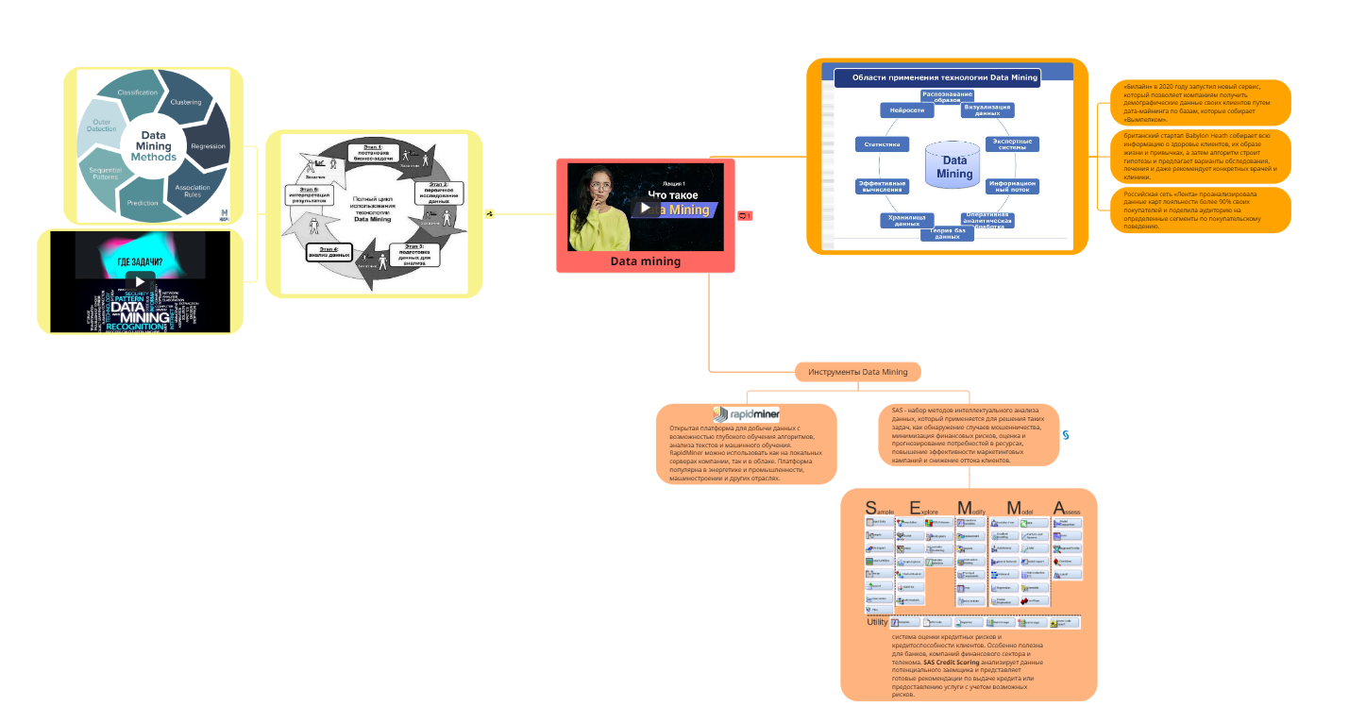  
<https://www.mindomo.com/mindmap/fe55224c8b474b8d8b8b2f4d146b85c3>